Data Science & Visualization (24ADI204)
WEEK 6 REPORT
Feature Engineering, Normalization, Scaling and Encoding
Team 8
Academic Year 2026
Course Code: 24ADI204
Dataset: Ames Housing Dataset (Iowa, USA)

1. Introduction
This Week 6 report covers Feature Engineering, Normalization, Scaling, and Categorical Encoding for the Ames Housing dataset under course 24ADI204 (Data Science & Visualization). Continuing from the clean Week 5 dataset (2,930 rows x 82 columns), this milestone constructs domain-specific features, mitigates target skewness via log transformation, evaluates and compares three major feature scaling techniques, encodes ordinal and nominal categorical variables, and exports the final matrix (2,930 rows x 293 columns).
2. Dataset Used
The input dataset for Week 6 is Cleaned_AmesHousing_Week5.csv, containing 2,930 verified records and zero missing values across 82 attributes. All original rows and columns were preserved prior to feature transformations.
3. Feature Classification
Attributes were categorized into three operational classes:
1. Numerical Features (39): Continuous physical measurements (e.g., Gr Liv Area, Total Bsmt SF) and discrete counts (e.g., Garage Cars, Bedroom AbvGr).
2. Nominal Categorical Features (33): Unordered categories (e.g., Neighborhood, House Style, MS Zoning, Sale Condition).
3. Ordinal Categorical Features (10): Inherently ordered ratings (e.g., Exter Qual, Kitchen Qual, Bsmt Qual, Heating QC).
4. Feature Engineering (Domain Creation)
Five new domain-specific features were engineered to capture combined architectural and temporal effects:
• HouseAge = Yr Sold - Year Built (Age of property at time of sale)
• RemodAge = Yr Sold - Year Remod/Add (Years since last remodeling)
• TotalBathrooms = Full Bath + (0.5 * Half Bath) + Bsmt Full Bath + (0.5 * Bsmt Half Bath) (Combined bathroom capacity)
• TotalPorchArea = Open Porch SF + Enclosed Porch + 3Ssn Porch + Screen Porch + Wood Deck SF (Total outdoor living area)
• TotalHouseArea = Gr Liv Area + Total Bsmt SF (Total combined indoor square footage)
5. Skewness and Transformation
Right-skewed target variable SalePrice (skewness = +1.74) was transformed using log1p(x) = log(1 + x). The log-transformed target SalePrice_Log reduced skewness to +0.12, achieving an approximately normal bell-curve distribution required for parametric modeling.
6. Feature Scaling Methods & Comparison
Three scaling algorithms were evaluated on key numerical features:
1. Min-Max Normalization: X' = (X - X_min) / (X_max - X_min). Bounds features strictly within [0, 1].
2. Standardization (Z-Score): Z = (X - mu) / sigma. Centers features at mean = 0 with standard deviation = 1.
3. Robust Scaling: X' = (X - median) / IQR. Uses median and IQR, making it robust against extreme outliers.
Feature | Orig Mean | Orig Std | MinMax Mean | MinMax Std | StdScaler Mean | StdScaler Std | Robust Mean | Robust Std
Gr Liv Area | 1,499.69 | 505.51 | 0.2196 | 0.0952 | 0.0000 | 1.0000 | 0.0935 | 0.8195
Total Bsmt SF | 1,051.26 | 440.97 | 0.1721 | 0.0722 | 0.0000 | 1.0000 | 0.1205 | 0.8670
Garage Area | 472.66 | 215.19 | 0.3176 | 0.1446 | 0.0000 | 1.0000 | -0.0287 | 0.8404
HouseAge | 36.43 | 30.29 | 0.2732 | 0.2211 | 0.0000 | 1.0000 | 0.0518 | 0.6444
TotalHouseArea | 2,550.95 | 805.25 | 0.1942 | 0.0705 | 0.0000 | 1.0000 | 0.0999 | 0.8128

7. Categorical Encoding
Categorical variables were encoded based on their structural property:
• Ordinal Encoding: 10 quality ratings (e.g., Exter Qual, Kitchen Qual) were mapped to integer ranks (None:0, Po:1, Fa:2, TA:3, Gd:4, Ex:5) to preserve rank order.
• One-Hot Encoding: 33 nominal attributes (e.g., Neighborhood, House Style, MS Zoning) were expanded into binary dummy columns, creating 211 binary features without imposing false numeric ordering.
8. Final Feature-Engineered Dataset
The processed data was exported to Feature_Engineered_AmesHousing.csv. The output matrix consists of 2,930 rows and 293 columns, fully numerical, scaled, and encoded.
9. Key Findings
1. Domain Feature Value: New features like TotalHouseArea (r = +0.813) and HouseAge (r = -0.558) show stronger correlation with price than isolated raw variables.
2. Normalization Success: log1p transformation successfully reduced target skewness from +1.74 to +0.12.
3. Scaling Appropriateness: MinMaxScaler is suited for bounded neural networks, StandardScaler for linear models, and RobustScaler for outlier-prone spatial features.
4. Dimensional Expansion: One-hot encoding expanded dataset dimensions from 82 to 293 numerical columns.
10. Important Visualizations
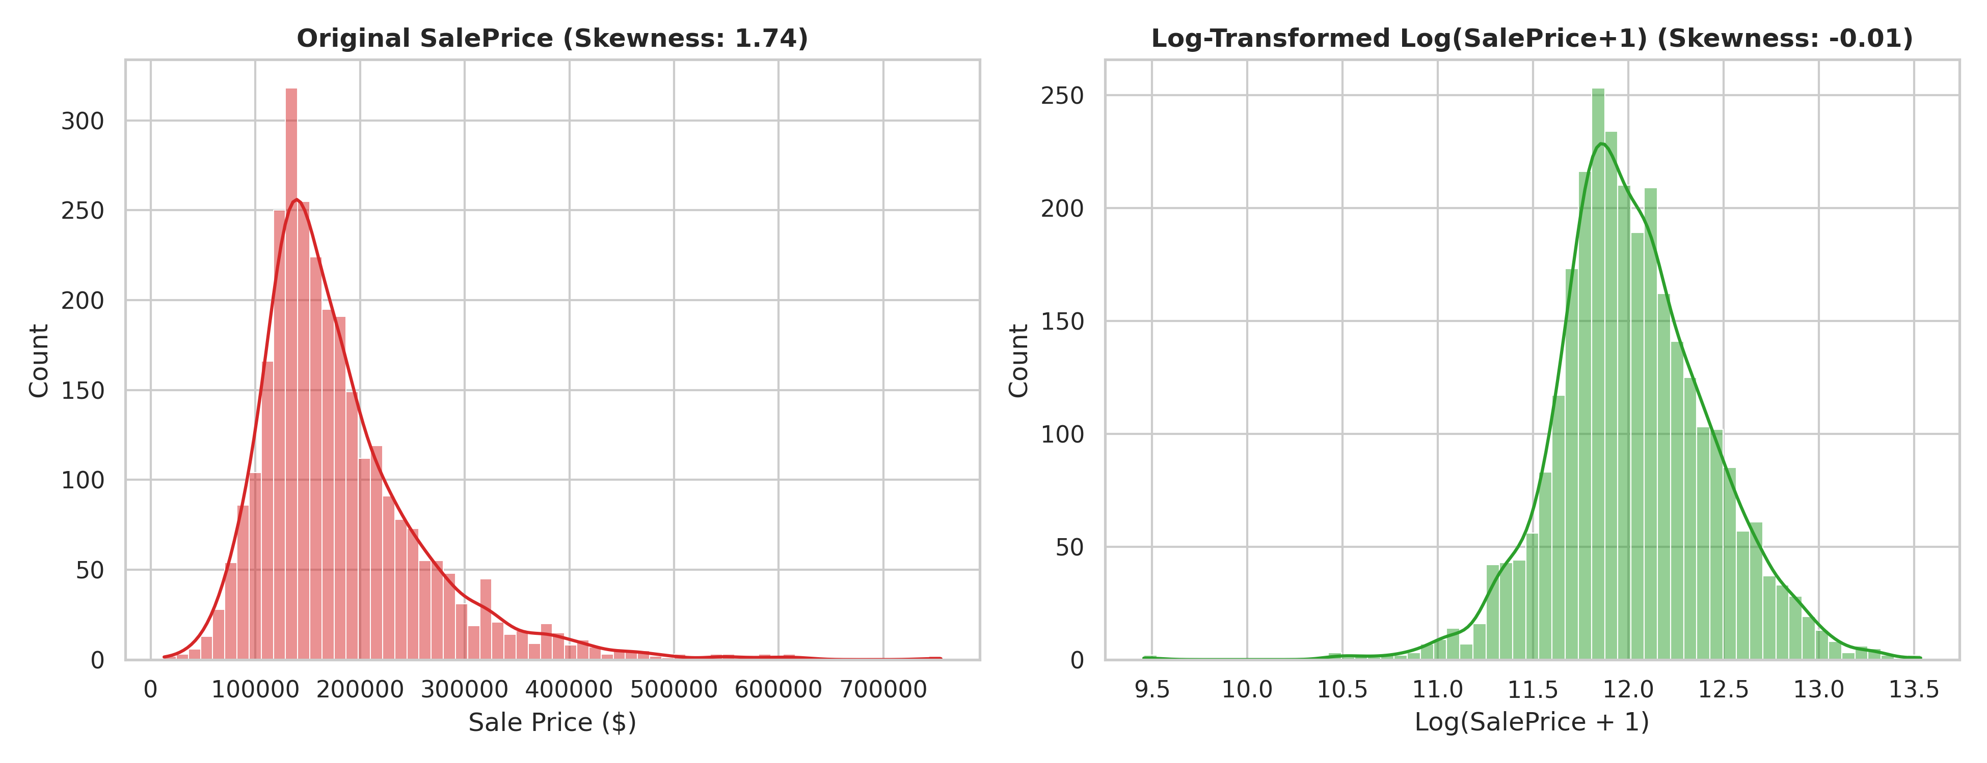
Figure 10.1: SalePrice Distribution Before and After Log Transformation
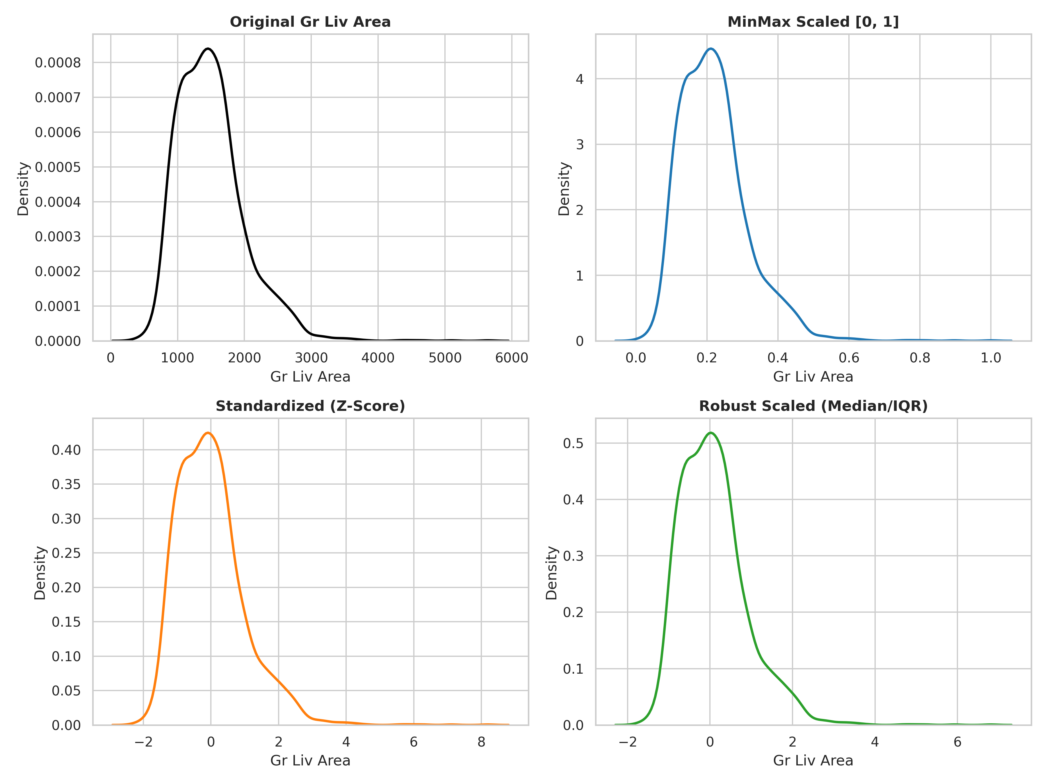
Figure 10.2: Visual Comparison of Feature Scaling Methods (Gr Liv Area)
11. Conclusion
Week 6 Feature Engineering successfully transformed the Ames Housing dataset into a high-dimensional, normalized numerical matrix. All categorical attributes are encoded, missing values remain zero, and scaling is validated. This dataset (Feature_Engineered_AmesHousing.csv) is now prepared for Week 7: Dimensionality Reduction – Feature Selection and PCA (note: full PCA is deferred to Week 7).

